**RESUME OF**

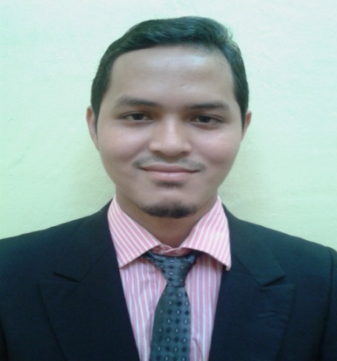

**ABDULL HANIF BIN ABDULL RAHMAN**

|  |
| --- |
| **GENERAL INFORMATION** |

|  |  |
| --- | --- |
| **Age** : 28 years old  **Nationality** : Malaysian  **Date of Birth** : 31 May 1988 | **Gender**  : Male  **IC no.**  : 880527-29-5211  **Marital Status** : Single |

**Address** : No.35, Kg Pauh Ganja, 16250 Wakaf Bharu,Tumpat,Kelantan.

**Mobile No.** : 013- 4075292

**Email** : abdullhanif007@gmail.com

|  |
| --- |
| **EDUCATIONAL BACKGROUND** |

**Highest Education**

**Level** : Degree of Mechanical Engineering (Automotive)

**CGPA** : 2.68

**Institute** : Universiti Teknikal Malaysia Melaka

**Graduation Date** : June 2010 – June 2013

**Level** : Diploma of Mechanical Engineering (Automotive)

**CGPA** : 3.38

**Institute** : Polytechnic of Kota Bharu

**Graduation Date** : June 2006 - June 2009

**Secondary Level Education**

**School** : Sekolah Menengah Kebangsaan Ayer Lanas,Jeli Kelantan

**Level** : Sijil Peperiksaan Malaysia (SPM)

**Year** : 2001 – 2005

|  |
| --- |
| **EMPLOYMENT HISTORY** |

**Company Name** : Sime Darby (Plantation)

**Position level** : Cadet Engineer

**Duration :** September 2015 – Now

**Company Name** : Adni Food & Drink Sdn. Bhd.

**Position level** : Managing

**Duration :** January 2015 – July 2015

**Company Name** : Tamaco Oil Mill (2) Sdn. Bhd.

**Position level** : Practical Trainee

**Duration :** June 2012 – August 2012

**Company Name** : Puspakom Sdn. Bhd.

**Position level** : Vehicle Examiner

**Duration** : Sept 2009 – June 2010

**Company Name** : Mie Technipart Sdn. Bhd.(ProtonServis Dealer)

**Position level** : Technician

**Duration** : July 2009 – Sept 2009

**Company Name** : PK Automobil (M) Sdn. Bhd.(Perodua Servis Center)

**Position level** : Practical Trainee

**Duration** : January 2008 – Jun 2008

|  |
| --- |
| **ACTIVITIES & ACHIEVEMENTS** |

* Autodesk AutoCAD Certified Associate (AutoCAD) 2013
* Industrial Trainee Discharge Certificate 2012
* Participant in Futsal and Bowling Tournament 2012

## Third place in Young Inventors UTeM 2011

* Fasilitator Minggu Haluan Siswa (MHS) 2011
* Smoke Meter Operating Certificate 2010
* Soft Skill Module Industial Training 2008
* Basic Application of Information Technology Skill Certificate 2007

|  |
| --- |
| **COMPUTER SKILLS** |

|  |  |  |  |  |  |
| --- | --- | --- | --- | --- | --- |
| **Skill** | |  | | **Proficiency** | |
| MS Office (word, excel, power point) | |  | | Excellent | |
| AutoCAD  Catia | |  | | Excellent  Excellent | |

|  |
| --- |
| **LANGUAGES** |

|  |  |  |
| --- | --- | --- |
| **Language** | **Spoken** | **Written** |
| Bahasa Malaysia | Excellent | Excellent |
| English | Good | Good |

|  |
| --- |
| **ADDITIONAL INFORMATION** |

**Additional Skills:**

* Posses a D and B2 class driving license
* Experience in vehicle services

|  |  |
| --- | --- |
| **Expected Monthly Salary** | : RM 2500 |
| **Willing to Travel** | :Yes |
| **Willing to Relocate** | :Yes |
| **Posses Own Transport** | :Yes |

|  |
| --- |
| **REFERENCES** |

**Name** :Mr. Zulaffandi bin Samad

**Telephone no.** : 019-77056646

**Position** : Mill Manager

**Company** : Sime Darby Plantation Sdn Bhd

**Name** :Mr. Solahadden

**Telephone no.** : 019 - 6017321

**Position** : Assistant Manager

**Company** : Sime Darby Plantation Sdn Bhd